Human Impacts on Coastal Ecosystems
Fish Necropsy

Time: 35 minutes
Group Size: 10-15 students
Grade Levels: 9th – 12th grade
Location: At Sea

OVERVIEW OF ACTIVITY

Students will participate in the necropsy of several mackerels. They will identify various parts of the internal and external anatomy and study these organs for signs of health. Using visual aids and microscopes, smaller student groups will ‘specialize’ in one of these internal structures, taking an in-depth look for signs of pollution or other human impacts. Fish will also be measured and compared to average expected sizes for that species. Students will then discuss any evidence of illness or poor function, possible causes, and the potential impacts a smaller or less healthy population of fish could have on world oceans.

PERFORMANCE OBJECTIVES

Students will be able to:
- Identify the internal and external systems of the fish that are used to diagnose ecosystem health, including stomach, gills, liver, heart, and skin/scales.
- Explain the relationship between the surrounding environment and fish digestion, respiration, and the appearance of the skin.
- Understand how the absence of large fish populations can be an indicator of poor ocean health and can lead to an imbalance in the food web.
- Realize that fish health and populations are dependent on a number of complex factors, including pollution, overfishing, disease, and ocean chemistry.

CHALLENGE

Determine how the structure and appearance of the mackerel’s internal organs indicate the health of this fish and the conditions of its habitat.

MATERIALS

- Thawed mackerels
- Dissection equipment: pan, scissors, tweezers, and probe
- Fish dissection posters and sheets, including External Anatomy/Internal Anatomy of a Fish, Fish Adaptations and Fish Diseases cards
- Magnifying lenses
- Towels and other cleaning supplies
- Microscopes
- Measuring tape or rulers

ADVANCE PREPARATION

- Take the fish out of the freezer to thaw.
- Put out sheets at each table. Make sure each “specialist group” table has a different organ.
- Set the dissecting equipment near the dissection tables.
- Set out cleaning supplies.
- Put out one magnifying lens and one microscope per “specialist group” table.

TEACHING TIPS
- It is easy to go long on this station so watch your time. Don’t forget to leave time for station clean up. You must move on when the next group is ready.
- The fish are kept in the Ecology kitchen upright freezer. Make sure to let the program director know if the box is getting low. Thaw the fish in cool water—never use hot water. When you clean up after your dissection, wrap the fish in newspaper, and put the bundle in the small trashcan. Rinse dissecting pans and tools between groups and clean completely after the program. Clean table and cards and reset for the next group.
- Be a facilitator, not a lecturer. Move between “specialist groups” to make sure they’re dissecting correctly and discussing what they’re seeing.
- Staff and volunteers can use gloves if they want, but the gloves are not for the students.

PROCEDURE

Engage (2 minutes):
- What is the purpose of a necropsy? (To determine the cause of death or health at the time of death of an animal.)
- What information will we need to determine the state of the mackerel’s habitat?
- What can we use to prove that there have been human-caused changes in its environment? (We can dissect and look at stomach contents, gills, heart, liver, and skin.)
Explore (25 minutes):
- As a group, briefly develop a hypothesis about Mackerel habitat based on its external anatomy.
- Dissection Procedures: Have the students put down all dissection tools and listen to your directions. Make sure to say they will all be participating in the dissection. Cut with the scissors starting at the anus and continuing between the pelvic fins to the narrow spot between the gills. Cut down from the anus down each side to help it open up. Have each interested student take part in the cutting—do not force anyone but encourage all to participate.
- Point out the Marine Disease Cards. Have students familiarize themselves with common signs of disease. Students should already be sitting in their “specialist groups” as the tables will be arranged that way during set-up.
- Each group first MEASURES their fish and records the size.
- Each Specialist Group will be focusing on the study of one particular organ: the gills, liver, heart, or scales. Each group should have cards on their table showing pictures of healthy versus unhealthy organs. They will remove samples of their organ, study them under hand lenses and microscopes, and record their observations. Their goal should be to determine whether or not that organ shows signs of disease or an unhealthy habitat.
- Once all small groups have recorded their individual observations, dissect the stomachs as a large group.

Explain and Extend (10 minutes):
Explain: Each specialist group shares their observations, then measurements and stomach contents are discussed.
- Scales and Skin: After observing the scales and skin, what would you determine about the health of this Mackerel? What signs led you to this analysis? (Discoloration of the scales, tears or inflammation in the skin, etc.)
- Liver and Heart: Based on the appearance of these organs, what can you ascertain about the overall health of the organism? What, if any, signs of disease were present? (Answers will vary but can include cysts or spots.) Why are these organs so important in the function of the body as a whole? (The heart pumps blood to the whole body, and the liver plays a role in waste disposal and chemical balance.)
- Gills: What observations did you make about the respiratory health of your fish? Why are the gills such an important indicator of ecosystem health and fish health? (They are in direct contact with the water, and also responsible for collecting oxygen out of the water, so if oxygen levels are low, they will be immediately affected.)
- Measurements: Share the size of each fish and relate it to average expected size for mackerels. (Maximum recorded size for the Pacific Mackerel is 81 centimeters. Today, 45 centimeters is considered ‘trophy size’. In the 1920s-30s, the average size of mackerels caught at San Pedro was 38 centimeters.) Most likely the sizes of the fish we dissect will be significantly less than this. What are some factors that contribute to smaller body sizes? (Diseases caused by pollution can in turn reduce population size, removal of large fish by fishermen, lack of food due to human impacts, etc.) Use the “Pacific Mackerel Body Lengths Over Time” graph as a visual aid.
- Stomach: Based on your observations, what do you think this fish eats? Did it eat a lot before it died or was its stomach empty? Was there a wide variety of food inside, or only one or two different items? How does this reflect what may be occurring in the rest of the food web? (Answers will vary.)
- As a group, discuss these results and ask: using all of this data, what can we say about the health of these fish and their ocean environment?

Extend:
- How do fish like mackerel play an important part of the food chain?
- If this species’ population becomes too low, how will that affect organisms below and above them on the food chain?
- What other human impacts can affect a fish population besides pollution? (Overfishing, habitat destruction.)
- Share some info from the Background Information above to engage students in a brief discussion of the biological, economic, and social impacts of overfishing, and possible solutions. It’s very important to discuss solutions so this station isn’t completely “doom and gloom”.

Evaluate (2 minutes):
- What are some possible solutions to ensure that fish populations stay healthy and thriving for future generations?
- What other organs could have been observed to assess the health of the mackerel? Explain.

RECOMMENDED ASSESSMENT STRATEGY
Observe and actively assist the students as they investigate the external and internal anatomy, providing feedback as necessary. Use the discussion questions and individual discoveries to guide understanding. The goal is not to definitively determine the health of the world ocean, but to discuss how these animals can act as indicators of human-caused problems in their habitats.

ACTIVITY RESOURCES

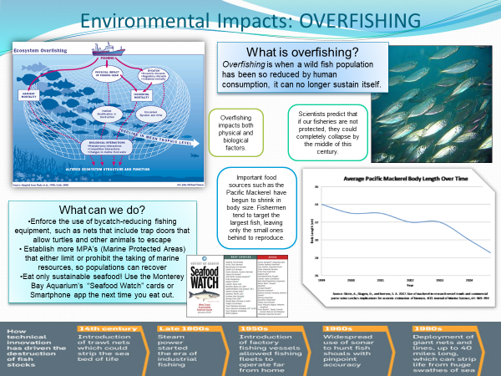
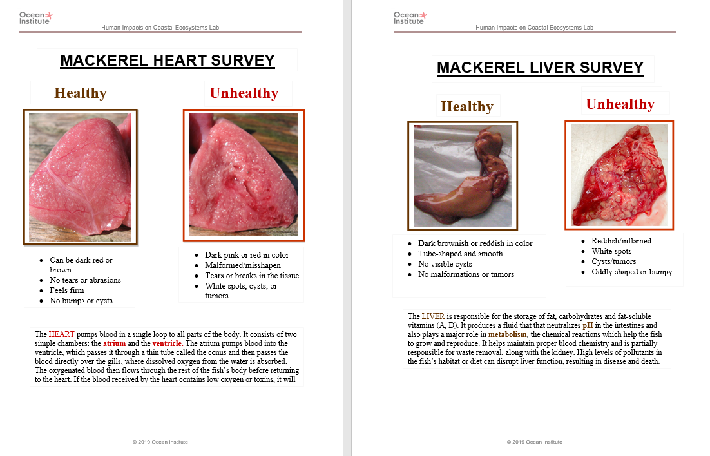
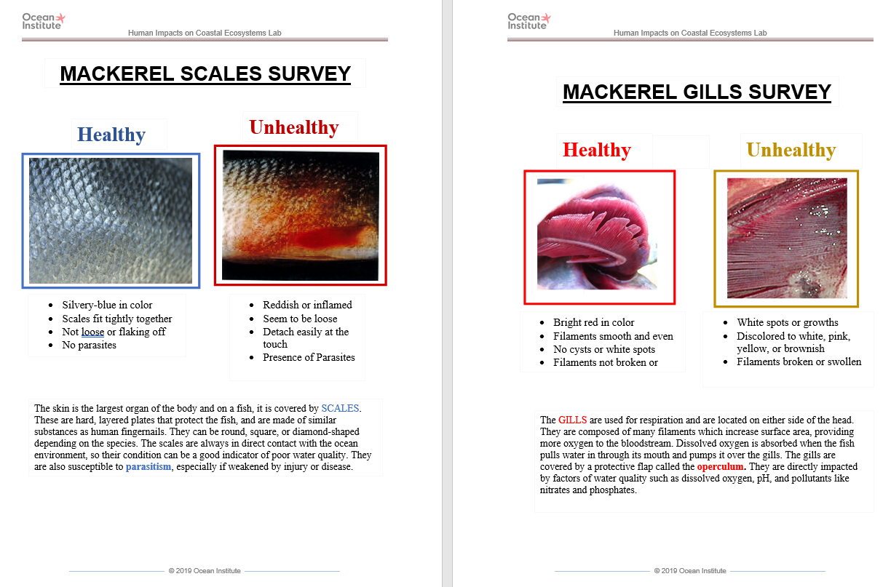
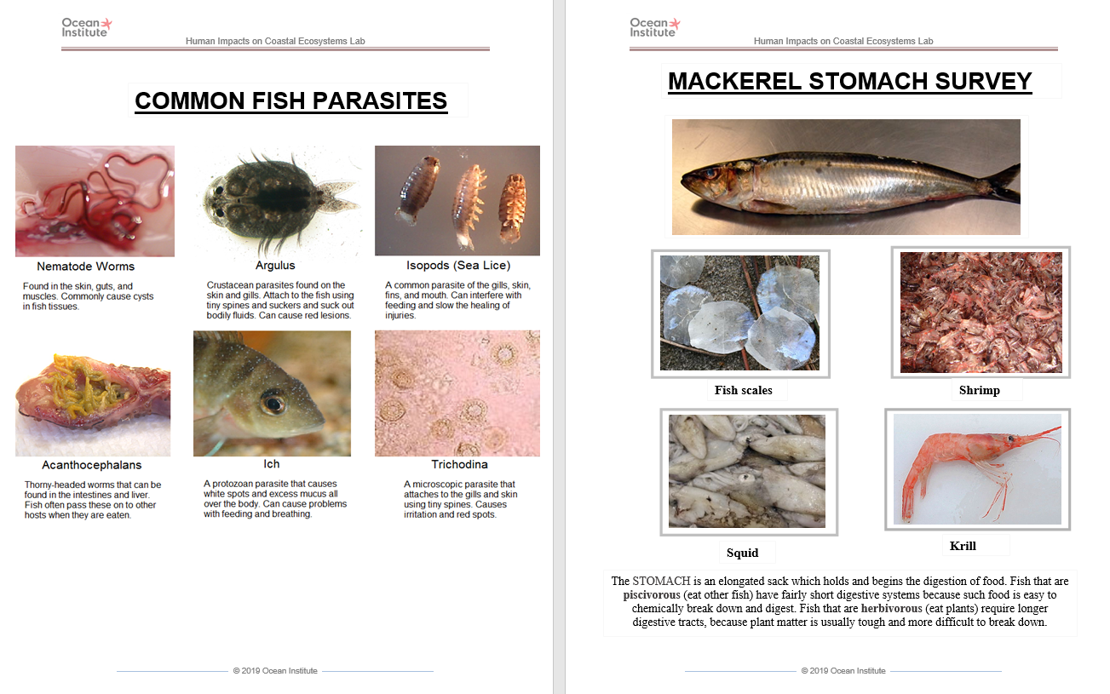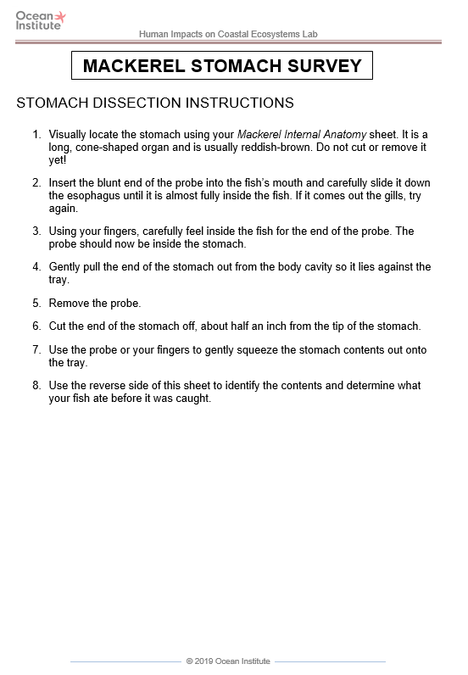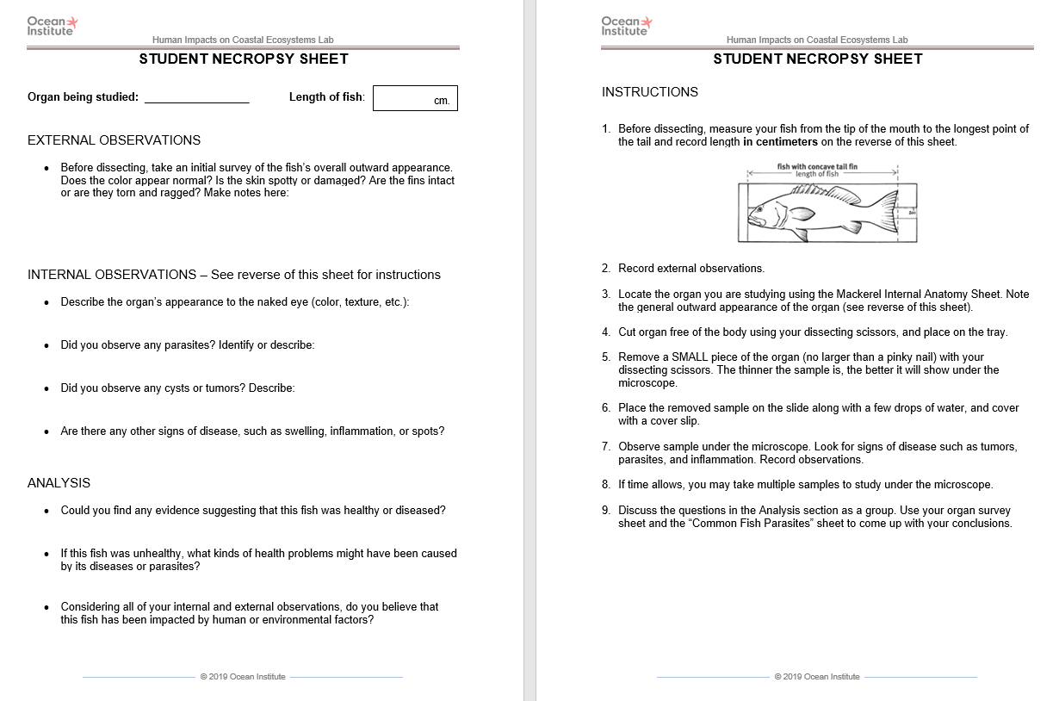

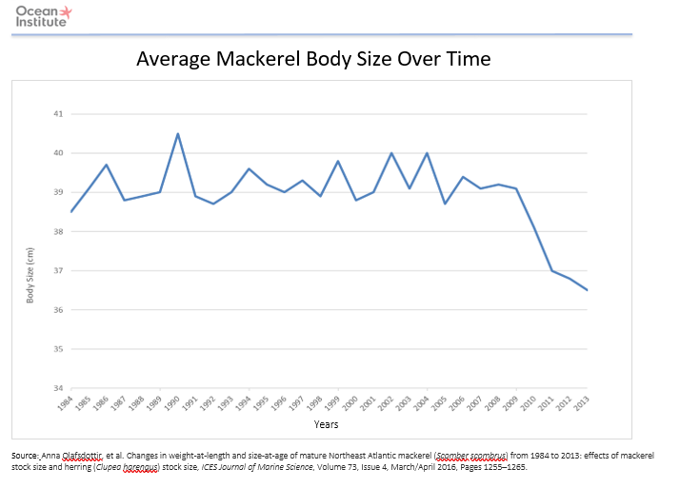
BACKGROUND INFO

The function of each organ inside any living thing’s body is a direct result of the environment it lives in. In the ocean, human factors such as pollution, overfishing, and ocean acidification can also affect the health of fish populations. Below is a brief overview of the organs emphasized in this station:

Stomach - holds and breaks down the food - shows adaptations in shape. Stomach contents are an indicator of what kind and how much food was available in that fish’s habitat.

Gills – used for respiration. They are directly impacted by factors of water quality such as dissolved oxygen, pH, and pollutants like nitrates and nitrites.

Heart - pumps blood to all parts of the body. If the blood received by the heart contains low oxygen, it will affect the entire body’s function.

Liver – storage of fat, carbohydrates and fat-soluble vitamins (A, D). It produces bile that neutralizes pH in the intestines. It helps maintain proper blood chemistry and also plays a role in waste (nitrogen) excretion.

Skin and scales – the largest organ of the fish. It is in direct contact with the ocean environment at all times, so it’s a good indicator of poor water quality.

Fish such as the Pacific Mackerel, Scomber japonicus, are a hugely important part of the ocean food web. They are a food source of larger predators, as well as a consumer of smaller animals such as squid and shrimp. As such they can be considered to be in the vital “middle” trophic level of the food web. They are also a main target of commercial fishing. Over the last century, fishing technologies have become so efficient that they are able to catch more fish than are actually available in the ocean. Fish are caught more quickly than they can reproduce to maintain their populations. These reduced populations are much more susceptible to inbreeding and disease. In 1990, global fleet capacities (the amount boats were able to catch) were over 6 million tons, while the total catch for that year was only about 2 million tons (Source: Worldwatch Institute). Many governments provide large subsidies to encourage the development of more efficient fishing technologies, but overall there are simply not enough fish left in the oceans to fulfill capacities. In addition, many methods used by commercial fishermen (such as longlining, trawling, and drift nets) result in huge amounts of bycatch – unintended catch such as small fish, dolphins and sea turtles. Up to 25% of ALL biomass caught worldwide each year is bycatch (Source: UNEP).

Management policies also play a role. The people who make decisions about what to fish and how much to fish, are under a lot of pressure from stakeholders such as fishermen, politicians, scientists and conservationists. Some groups want to promote as much fishing as possible while others want to create marine protected areas (MPA’s) where no fishing would be allowed, relieving pressure on the populations there. In most cases, regulations relating to catch limits are loose and very difficult to enforce. Each season in any given fishery the largest and most fecund fish are removed from the environment, resulting in lower reproductive rates for the entire population. As a result, ocean fish are in general much smaller than in the past; for example, in the 1960’s an average swordfish was over 250 pounds, while now the average weight is only 90 pounds (Source: SeaWeb). This means that people who depend upon catching these fish for a living are beginning to lose income and jobs. Over a billion people around the world rely on seafood as a main source of protein, and the majority of these people are living in poverty (Source: George Kent, 1997, “Fisheries, Food Security, and the Poor”, Food Policy Vol. 22). Even wealthy countries such as the United States are facing challenges. On the West Coast, the situation has grown so bad that in 2000, the groundfish fisheries were declared a federal disaster by the Department of Commerce (Source: SeaWeb). Today, 70% of the planet’s marine stocks are considered exploited or over-exploited (Source: United Nations Food and Agriculture Organization).

“The commercial fishery for Pacific mackerel has changed considerably over the past century. This fish supported one of California’s major fisheries during the 1930s and 1940s and, even more recently, in the 1980s and 1990s. In the early days of the fishery, Pacific mackerel were harvested with sardines and sold fresh and later, canned. Landings decreased in the early 1930s due to the Great Depression and the resulting decline in demand but increased significantly by the mid-1930s (66,400 metric tons in 1935–1936). Unfortunately, the stock collapsed in the mid-1960s. Harvests declined but for many years, demand for canned mackerel remained steady and exceeded supply. Supply reached record low levels in the early 1970s, and the State of California placed a moratorium on the directed fishery. The stock recovered from the mid to late 1970s, and the moratorium was lifted. Through the 1990s, the fishery ranked third in volume for fish landed in California, but the market for canned mackerel fluctuated due to availability and economic conditions. Domestic demand for canned Pacific mackerel eventually died out and the last mackerel cannery in California closed in 1992. Today, managers continue to actively manage the fishery, although recent landings have been well below harvest guidelines – just over 2,000 metric tons in 2010.” (Source: NOAA FishWatch)

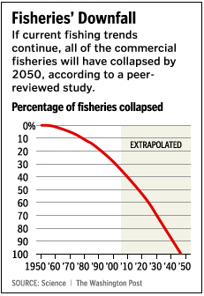
There are solutions that can address some of these issues. Many countries are now enforcing the use of bycatch-reducing fishing equipment, such as nets that include TED’s (Turtle Excluder Devices) – trap doors that allow turtles and other animals to escape. More and more MPA’s are being established that either limit or prohibit the taking of marine resources, allowing these populations to recover. Furthermore, aquaculture sites – artificial fish farms – are becoming more popular. Nearly a third of fish grown for food are harvested from aquaculture (Source: United Nations Food and Agriculture Organization). By producing fish in a farm, there is a reduced need to fish from the wild ocean where fish are potential reproducers. However, fish farms have their drawbacks as well: they produce a lot of waste that can escape into the ocean as pollution, the fish are prone to diseases that can transmit to wild populations, and they often require the destruction of natural areas such as mangroves and estuaries. However, aquaculture techniques are constantly being improved, and several species raised primarily in farms such as tilapia have received “Best Choice” status on Monterey Bay Aquarium’s Seafood Watch list (Source: Monterey Bay Aquarium). If we are to prevent a worldwide collapse of the fishing industry, all of these sustainable solutions must be explored by managers and stakeholders alike.
“Too often we have managed our fisheries the way we
maintain cars: we don’t fix them until they’re broken.
But we ought to approach fisheries management the
same way we maintain airplanes: doing everything we
can to keep the entire system in good working order.
After all – like airplanes – when fisheries have a
breakdown, they crash.”
-James Bohnsack, National Marine Fisheries Service

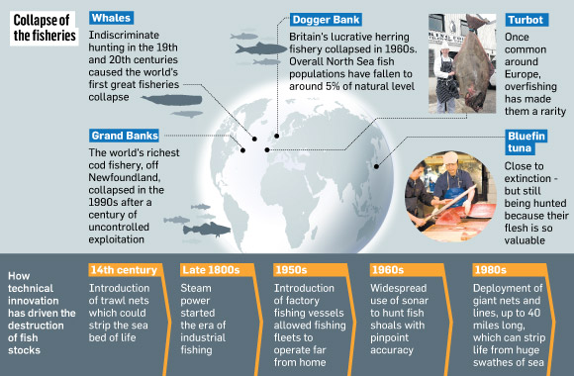

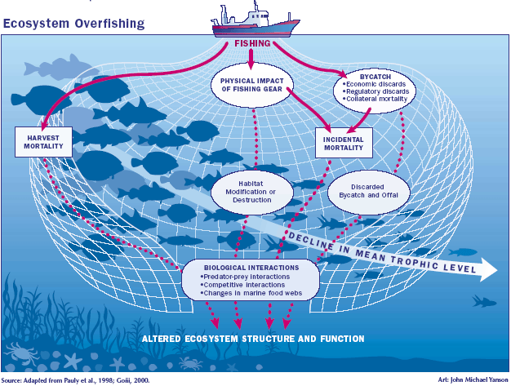

RESOURCES
Pacific Fishery Management Council – www.pcouncil.org

United States Marine Protected Areas – www.mpa.gov

SeaWatch – www.seawatch.org

Seafood Watch – www.montereybayaquarium.org/cr/seafoodwatch.aspx

American Fisheries Society – www.fisheries.org

National Fisheries Institute – www.nfi.org

Sea Grant – www.seagrant.noaa.gov

National Marine Fisheries Service – www.nmfs.noaa.gov

Aquatic Network – www.aquanet.com

Marine Fish Conservation Network – www.conservefish.org

Center for Marine Conservation – www.cmc-ocean.org

NOAA Fish Watch (with a page on Pacific Mackerel) - www.fishwatch.gov

